PROJECT-31
PDF CHATBOT
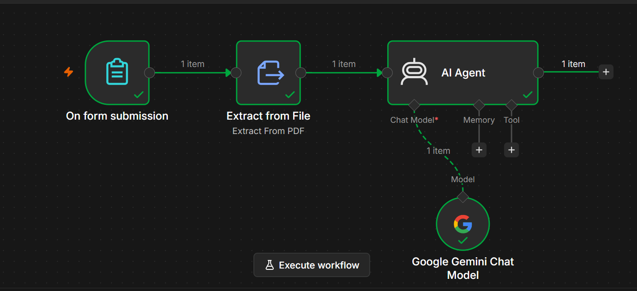
Project Objective
Build an AI chatbot that:
- Accepts a PDF uploaded by the user.
- Extracts text from the PDF.
- Uses Google Gemini to answer questions based only on the uploaded PDF.

Workflow Architecture
On Form Submission
│
▼
Extract from File
│
▼
AI Agent
│
▼
Google Gemini Chat Model

Nodes Used
Node | Purpose
On Form Submission | Receives the uploaded PDF and user's question
Extract from File | Extracts text from the uploaded PDF
AI Agent | Sends the extracted text and question to the AI
Google Gemini Chat Model | Generates the final response

Step 1: On Form Submission
Purpose
This node creates a web form where users can:
- Upload a PDF
- Ask a question

Form Elements
Element 1
Type
File
Label
Upload PDF
Field Name
pdf
Required
Yes

Element 2
Type
Text
Label
Ask your Question
Field Name
chatInput
Required
Yes

Output Example
{
"chatInput":"What is Artificial Intelligence?"
}
Binary Output
pdf

Step 2: Extract from File
Purpose
Reads the uploaded PDF and extracts all readable text.

Configuration
Operation
Extract From PDF
Input Binary Field
pdf

Output Example
{
"text":"Artificial Intelligence is a branch of computer science..."
}

Step 3: Google Gemini Chat Model
Purpose
Acts as the Large Language Model (LLM) for the chatbot.
No special configuration is required besides connecting your Gemini credentials.

Step 4: AI Agent
Purpose
Combines:
- User question
- Extracted PDF text
and asks Gemini to generate an answer.

Prompt (User Message)
If your form field is named chatInput:
{{ $json.chatInput }}

System Message
You are an AI PDF Assistant.

Use ONLY the information contained in the PDF to answer the user's question.

PDF Content:

{{ $node["Extract from File"].json.text }}

If the answer is not present in the PDF, reply:

"I couldn't find that information in the uploaded PDF."

Answer clearly, accurately, and concisely.

Workflow Execution
Step 1
User opens the generated form.
↓
Step 2
Uploads a PDF.
↓
Step 3
Types a question.
Example:
What is Machine Learning?
↓
Step 4
Submits the form.
↓
Step 5
Extract from File converts the PDF into plain text.
↓
Step 6
The AI Agent receives:
- The extracted PDF text
- The user's question
↓
Step 7
Gemini analyzes the content and generates an answer.
↓
Step 8
The response is returned to the user.

Example
Uploaded PDF
Artificial Intelligence is the simulation of human intelligence.

Machine Learning is a subset of Artificial Intelligence.

Deep Learning uses neural networks.

User Question
What is Machine Learning?

AI Response
Machine Learning is a subset of Artificial Intelligence.

Advantages
- Easy to build.
- No coding required.
- Uses Google Gemini for intelligent responses.
- Works well for small and medium-sized PDFs.
- Good beginner project for learning AI Agents in n8n.

Limitations
- Sends the entire PDF to Gemini with each request.
- Large PDFs (50–100+ pages) may exceed the model's context limit.
- Not optimized for searching across very large documents.

Future Improvements
You can enhance this project by adding:
- Memory to support follow-up questions.
- Text Splitter to break large PDFs into chunks.
- Embeddings to create semantic representations of the text.
- Vector Database (e.g., Qdrant, Pinecone, Chroma, Supabase) for efficient retrieval.
- RAG (Retrieval-Augmented Generation) so the AI searches only the most relevant sections of the PDF before answering.

Final Workflow
┌─────────────────────┐
│ On Form Submission │
│ • Upload PDF │
│ • Ask Question │
└──────────┬──────────┘
│
▼
┌─────────────────────┐
│ Extract from File │
│ Extract From PDF │
└──────────┬──────────┘
│
▼
┌─────────────────────┐
│ AI Agent │
│ System Prompt │
│ User Prompt │
└──────────┬──────────┘
│
▼
┌─────────────────────┐
│ Google Gemini Chat │
│ Model │
└─────────────────────┘
This is a solid beginner-level PDF Chatbot. As you continue toward your goal of building many AI agents, the next step is to evolve this into a RAG-based PDF Chatbot, which is the architecture commonly used in production AI document assistants.

